**Shipment Details Inquiry:** The Shipment Details Inquiry allows you to look up information about your submitted orders’ shipping status, including packaging and tracking details.

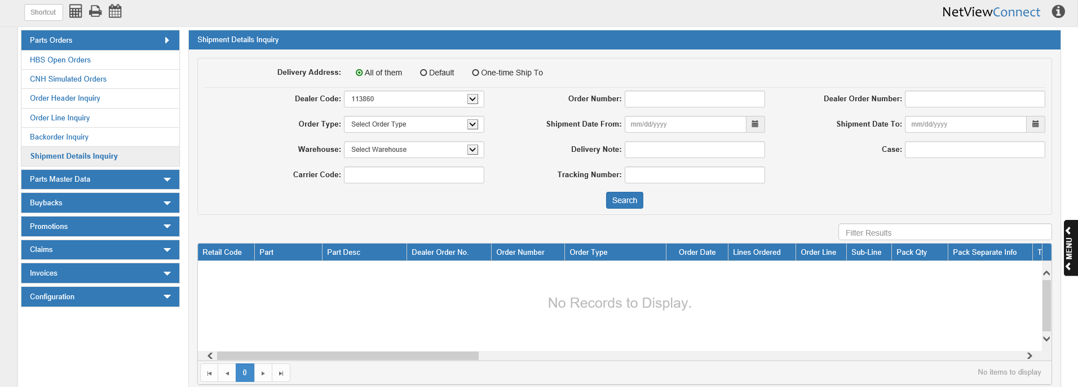

**Search Filter Fields:**

Delivery Address: Select what delivery address type you want to search by:

* Dealer’s default address (Default)
* One-time shipping address (One-time Ship To)
* Both (All of them—**default selection**)

Dealer Code: Select a dealer code to search by. This applies more to dealers that have more than one CNH dealer code, and may have attached different codes to different orders.

Order Number: To search by the CNH-assigned order number, enter the number here.

Dealer Order Number: To search by the dealer-assigned order number, enter the number here.

Order Type: To search by order type, select the type from the drop-down menu, then enter a date or range of dates in the Shipment Date From/To fields. **NOTE:** The program requires you to use the date search filter when using the order type filter.

Shipment Date From/To:

* To search by a **range** of shipment dates, enter the starting and ending dates of the range in these fields, or select them from a calendar.
* To search for a **single** shipment date, enter the date in both fields.

Warehouse: To search by warehouse, select the warehouse code from the drop-down menu.

Delivery Note: To search by the delivery note ID, enter the number here.

Case: To search by the case number, enter the number here.

Carrier Code: To search by the carrier code, enter the code here.

Tracking Number: To search by the tracking number, enter the number here.

**Search:** After setting your search filters, click this button to populate the results grid:

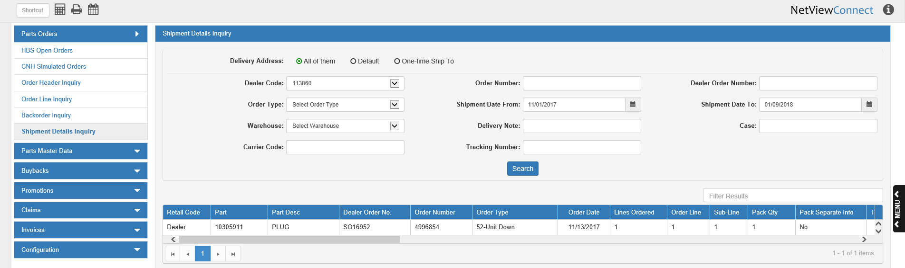

Note that each entry in the grid represents a single order line’s shipping information. You can sort the results using the column headers, or filter it by entering specific information in the **Filter Results** field.

**Column Definitions:**

Retail Code: This column shows the retail code for the order line.

Part: This column shows the part number for the order line.

Part Desc: This column shows the part’s description.

Dealer Order No: This column shows the dealer-assigned order number for the line.

Order Number: This column shows the CNH-assigned order number for the line.

Order Type: This column shows the order type for the line.

Order Date: This column shows the order’s creation date.

Lines Ordered: This column shows the total number of lines on the order.

Order Line: This column shows the order line number for this result entry.

Sub-Line: This column shows the sub-line number for this result entry.

Pack Qty: This column shows the package quantity being shipped for this order line.

Pack Separate Info: This column indicates if the part(s) were to be packed separately or not.

Tracking No.: This column shows the tracking number for the order line’s shipment. Clicking the number will show more tracking information in a new window:

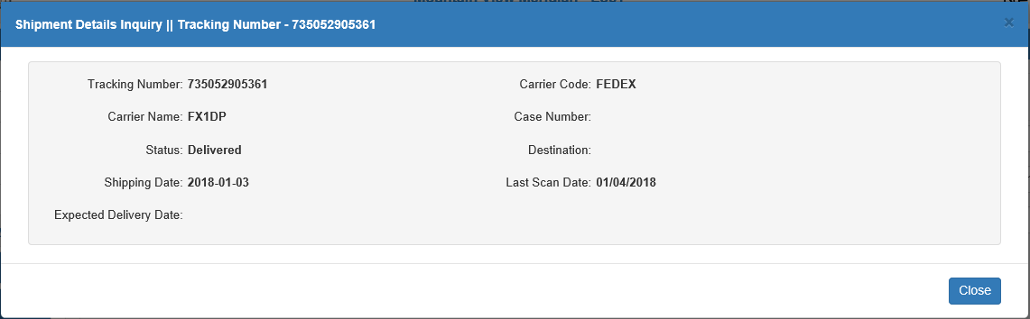

**Tracking Number:** This field shows the tracking number.

**Carrier Code:** This field shows the carrier code.

**Carrier Name:** This field show the carrier name.

**Case Number:** This field shows the case number, if applicable.

**Status:** This field shows the shipment’s current status.

**Destination:** This field shows the shipment’s destination, if available.

**Shipping Date:** This field shows the order’s shipping date.

**Last Scan Date:** This field shows the last date the order was scanned at a depot along the route.

**Expected Delivery Date:** This field shows the expected delivery date, if available.

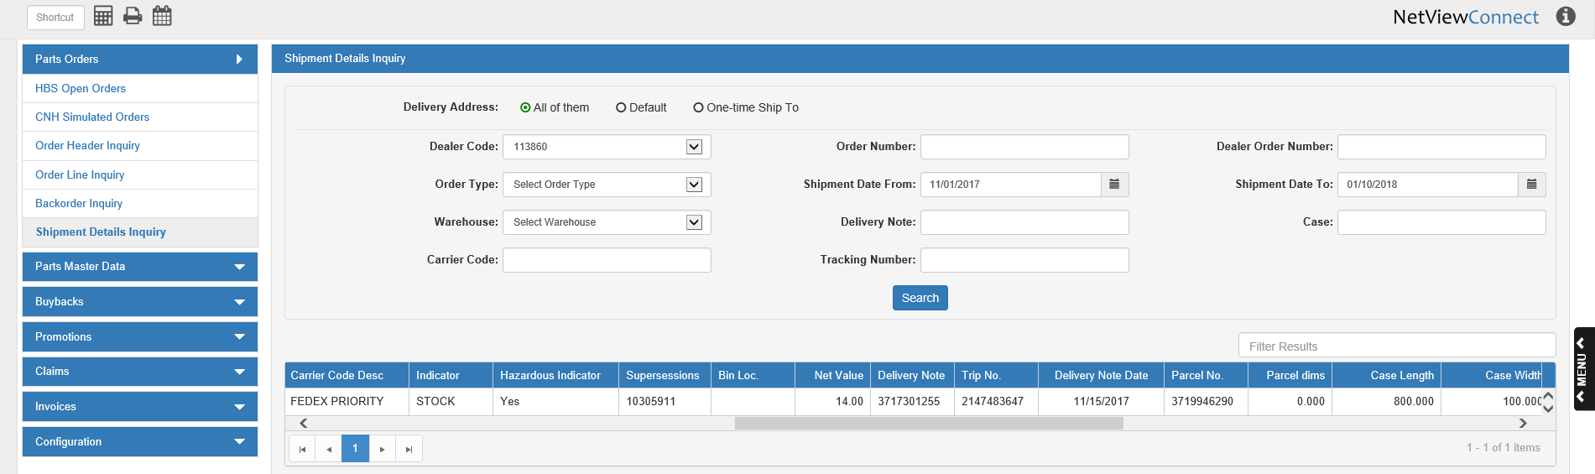

Carrier Code Desc: This column shows the carrier code description for the order line’s shipment.

Indicator: This column shows any indicator applied to the shipment.

Hazardous Indicator: This column shows if a hazardous indicator has been applied to the shipment.

Supersessions: This column shows any supersession part number for the order line.

Bin Loc: This column shows the bin location for the order line’s part, if available.

Net Value: This column shows the net value of the order line.

Delivery Note: This column shows the delivery note number.

Trip No.: This column shows the trip number for the shipment.

Delivery Note Date: This column shows the delivery note date.

Parcel No.: This column shows the parcel number for the shipment.

Parcel dims: This column shows the parcel’s combined total dimensions.

Case Length: This column shows the case length for the shipment.

Case Width: This column shows the case width for the shipment.

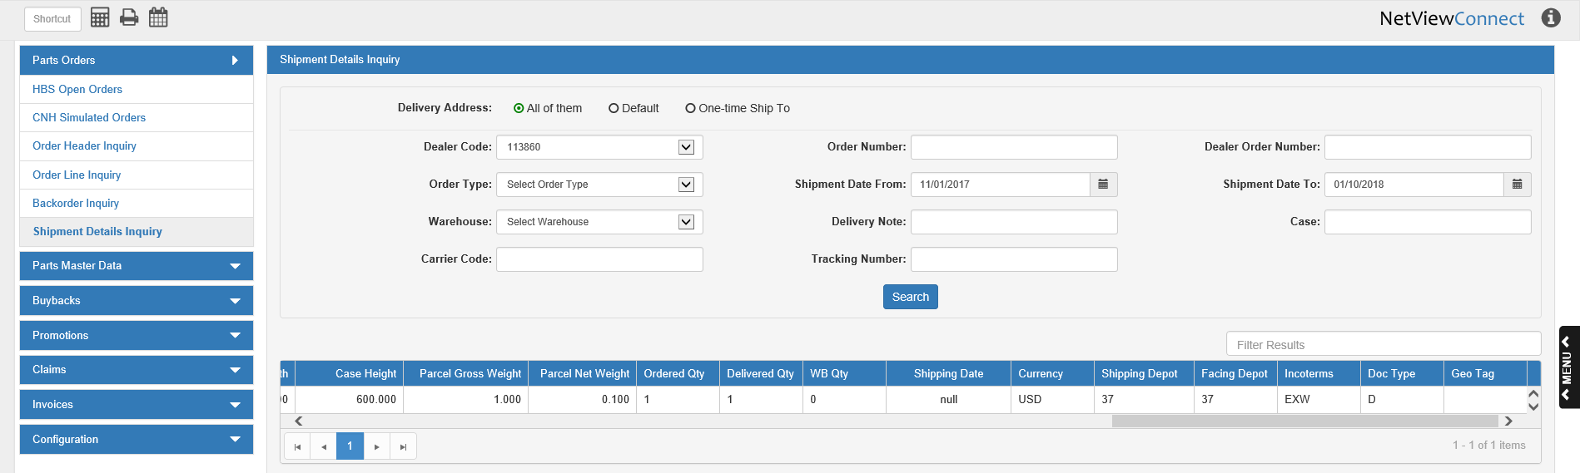

Case Height: This column shows the case height for the shipment.

Parcel Gross Weight: This column shows the parcel’s gross weight.

Parcel Net Weight: This column shows the parcel’s net weight.

Ordered Qty: This column shows the part quantity originally ordered on this line.

Delivered Qty: This column shows the quantity of the order line’s part actually delivered to the dealer.

WB Qty: This column shows the warehouse backorder quantity for the order line.

Shipping Date: This column shows the shipping date for the order line.

Currency: This column shows the type of currency used in the order transactions.

Shipping Depot: This column shows the shipment’s shipping depot.

Facing Depot: This column shows the shipment’s facing depot.

Incoterms: This column shows any incoterm that applies to the shipment.

Doc Type: This column shows the document type that applies to the order line.

Geo Tag: This column shows the geo tag information for the order line, if applicable.